<Google Classroom>

**Online Learning Platform**

Use-Case Specification: <Customize class>

Version <1.1>

Revision History

| **Date** | **Version** | **Description** | **Author** |
| --- | --- | --- | --- |
| 5/12/2021 | 1.0 | Initial version | Le Hong Hai |
| 9/12/2021 | 1.1 | Edited version | Le Hong Hai |
|  |  |  |  |
|  |  |  |  |

Table of Contents

1. Use-Case Name 3

1.1 Brief Description 3

2. Flow of Events 3

2.1 Basic Flow 3

2.2 Alternative Flows 3

2.2.1 < First Alternative Flow > 3

2.2.2 < Second Alternative Flow > 3

3. Special Requirements 3

3.1 < First Special Requirement > 3

4. Preconditions 3

4.1 < Precondition One > 3

5. Postconditions 3

5.1 < Postcondition One > 3

6. Extension Points 3

6.1 <Name of Extension Point> 3

Use-Case Specification: <Customize Class>

# Use-Case Name

-This process for user to customize class

- For who: user (teacher)

- The purpose: helping the teacher to change the theme of the teaching class.

# Flow of Events

## Basic Flow

First, at the top left, move mouse pointer to Menu icon (icon ) (when hovering over this icon, the mouse pointer will turn into a pointing hand icon, it will appear as a tooltip like a small box named “Main Menu '' with text color: white and background-color: black. Also, the menu icon background will be blurred a little bit with a gray circle around it).

Then, when clicking 1 time in this Menu icon (), Menu icon disappeared and a selection panel (background-color: white) will be displayed in left-side (including “Classes” with icon like a house in the left-side of “Classes” text, “Calendar”- under “Classes” with icon calendar in the left-side of “Calendar” text, “Enrolled” with “To-do” with notebook icon in the left-side of “To-do” text, user’s classes with different color cycle icon in the left-side of class’s name , “Archived classes” with save icon in the left-side of it and “Settings” with bolts icon in left-side of it respectively). Text-color in this selection panel is black.

When hovering the mouse pointer in “Teaching” part with any class (with class icon in left and name of class beside), the mouse pointer will turn into a pointing hand icon with text color: black and background will be blurred with gray color a little bit).

Then, click it 1 time into any teaching class. A new page will appear (with background-color: white; text: black).

In the middle top, there are names of options like “Stream”, “Classwork”, “People”, “Grades”. And now, the interface of this use case specification is in the “Stream” part.

In the top right, they are a bolts icon (), icon () and icon profile of the user respectively from left to right.

In the top left, they are Menu icon () on the left-side and text name of the teaching class on the right-side. Under, it is a rectangular box that describes the name of class “SAD Final Project (2021)”. In the top right of this box, it is a small rectangular “Customize” with icon () beside. The user can change the theme of the class by clicking on it.

When hovering in this small button, the background color will be blurred a little bit and mouse pointer will be turned into a pointing hand. Then, when the user clicks on it, there are 2 options displayed to choose “Upload photo” and “Select theme” under the icon in the left-side respectively.

When hovering in this part, the background color will be blurred a little bit and the mouse pointer will be turned into a pointing hand. Then clicking “Upload photo” a new box will be displayed named “Gallery” with background-color: white and text: black. User can upload a photo to upload by dragging and dropping a photo from computer to the part “Drag a photo here” (text-color: gray) with icon () above. The mouse pointer will be turned into a pointing hand when hovering in this part.

Also, users can click to “Select a photo from your computer” (like a small rectangular with background-color: gray; text-color: black, mouse pointer will be turned into a pointing hand when hovering in this part) to upload an image for class theme. When uploading is done, the user clicks the “Select class theme” (in bottom left with background-color: blue; text-color: white) to confirm the set theme for class. Otherwise, user click into button “Cancel” beside (with background-color: gray and text-color: black) or icon () in the top right of the “Gallery” part to dismiss the process.

In other way to customize the theme of class, user click to “Select theme” in below “Upload photo” in “Customize” part like description above (mouse pointer will be turned into hand pointer with background-color: gray blurred a little bit). When clicking on it, a new box will appear in the “Gallery” including small parts like “General”, “English & History'', “Math & Science ``,''Arts ``,''More ``. “More” has smaller parts “Sports”, “Other”. Part which is being chosen to be bold and underlined with color: blue. When user hovering any theme, it will be blurred background a little bit and display name of theme, mouse pointer turns into hand pointer. Then, user click to choose any theme, border will be bold with color: blue and displayed icon “check” like () in the top left of the theme. To confirm, the user clicks the “Select class theme” in the bottom left (background-color: blue; text-color: white, bold a little bit when hovering), then clicks it to set the theme. Finally, a notification “class theme uploaded” will be displayed in the left bottom (background-color: black, text: white).



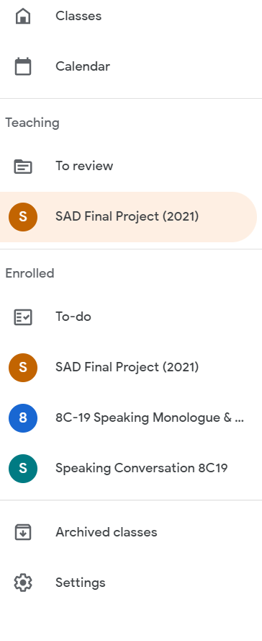

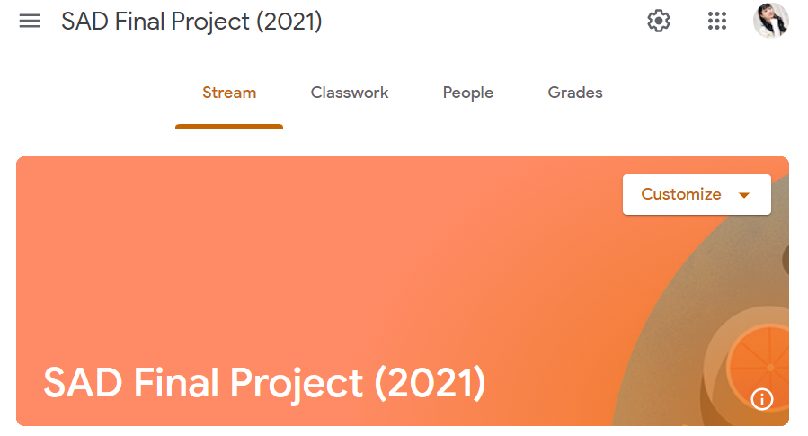

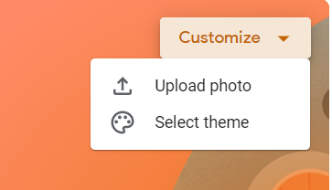

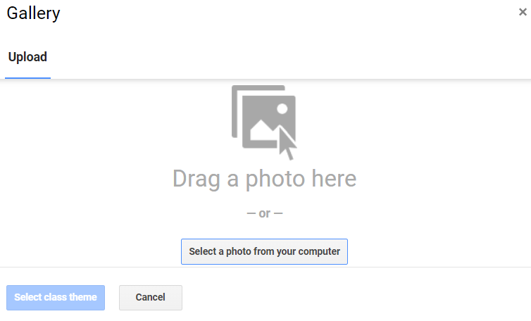

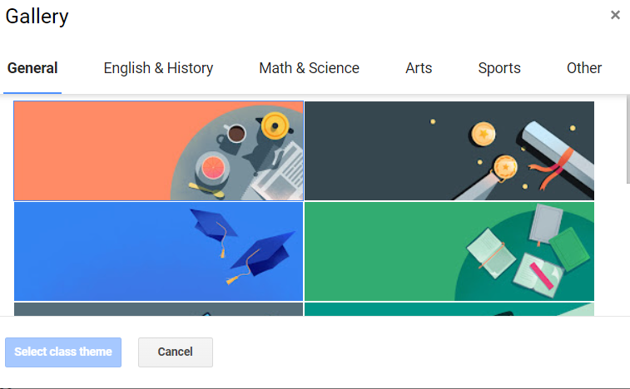

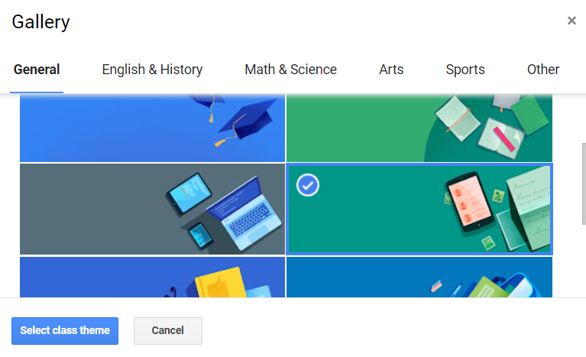

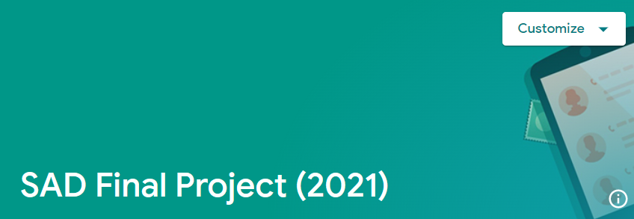

## Alternative Flows

None

# Special Requirements

## None

# Preconditions

Users must log in successfully first!

# Postconditions

## None

# Extension Points

## None